OBJECT ORIENTED PROGRAMMING

[CT-260]



NAME: ABDUL RAHEEM SHEIKH

ROLL NO: CT-25192

DEPARTMENT: BCIT

BATCH: 2025

YEAR & SECTION: FSCS-D

LAB: 06

Q1.
#include <iostream>
#include <cmath>
using namespace std;

class Shape
{
private:
int numSides;
float area;

public:
Shape(int sides, float a) : numSides(sides), area(a) {}
void setSides(int sides) { numSides = sides; }
void setArea(float a) { area = a; }
int getSides() { return numSides; }
float getArea() { return area; }
void display() {
cout << "Number of sides: " << numSides << endl;
cout << "Area: " << area << endl;
}
};

class Rectangle : public Shape
{
private:
float len, width;

public:
Rectangle(float l, float w) : Shape(4, 0), len(l), width(w) {}
void generateArea() { setArea(len * width); }
float getLength() { return len; }
float getWidth() { return width; }
};

class Circle : public Shape
{
private:
float radius;

public:
Circle(float r) : Shape(0, 0), radius(r) {}
void generateArea() { setArea(M_PI * radius * radius); }
};

class Triangle : public Shape
{
private:
float base, height;

public:
Triangle(float b, float h) : Shape(3, 0), base(b), height(h) {}
void generateArea() { setArea(base * height / 2); }
};

class Square : public Rectangle
{
public:
Square(float s) : Rectangle(s, s) {}
void generateArea() { setArea(getLength() * getWidth()); }
bool checkSide() {
if (getLength() == getWidth())
return true;
return false;
}
};

int main()
{
cout << "Rectangle:" << endl;
Rectangle rect(5, 3);
rect.generateArea();
rect.display();

cout << "\nCircle:" << endl;
Circle circ(4);
circ.generateArea();
circ.display();

cout << "\nTriangle:" << endl;
Triangle tri(6, 4);
tri.generateArea();
tri.display();

cout << "\nSquare:" << endl;
Square sq(4);
sq.generateArea();
sq.display();
cout << (sq.checkSide() ? "Sides are equal." : "Sides are not equal.") << endl;
return 0;
}

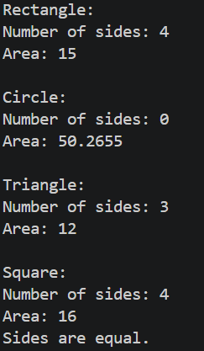
Q2.
#include <iostream>
using namespace std;

class Calculator
{
private:
float num1, num2, num3;

public:
Calculator()
{
cout << "Enter three numbers: ";
cin >> num1 >> num2 >> num3;
}
float add(float a, float b)
{
return a + b;
}
float add(float a, float b, float c)
{
return a + b + c;
}
float multiply(float a, float b)
{
return a * b;
}
float multiply(float a, float b, float c)
{
return a * b * c;
}
float subtract(float a, float b)
{
return a - b;
}
float divide(float a, float b)
{
if (b != 0)
{
return a / b;
}
else
{
cout << "Error: Division by zero!" << endl;
return 0;
}
}

void display()
{
cout << num1 << " + " << num2 << " = " << add(num1, num2) << endl;
cout << num1 << " + " << num2 << " + " << num3 << " = " << add(num1, num2, num3) << endl;
cout << num1 << " * " << num2 << " = " << multiply(num1, num2) << endl;
cout << num1 << " * " << num2 << " * " << num3 << " = " << multiply(num1, num2, num3) << endl;
cout << num1 << " - " << num2 << " = " << subtract(num1, num2) << endl;
cout << num1 << " / " << num2 << " = " << divide(num1, num2) << endl;
}
};

int main()
{
Calculator calc;
calc.display();
return 0;
}

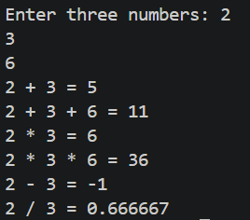
Q3.
#include <iostream>
#include <math.h>
using namespace std;

class Vector {
float x, y;
public:
Vector(float x, float y) : x(x), y(y) {}

Vector operator+(const Vector& other) {
return Vector(x + other.x, y + other.y);
}

Vector operator-(const Vector& other) {
return Vector(x - other.x, y - other.y);
}

Vector operator*(const float val) {
return Vector(x * val, y * val);
}

Vector operator/(const float val) {
if (val == 0) {
cout << "Error: Division by zero!" << endl;
return Vector(0, 0);
}
return Vector(x / val, y / val);
}

float magnitude() {
return sqrt(pow(x, 2) + pow(y, 2));
}

void display() {
cout << "Vector(" << x << ", " << y << ")" << endl;
}
};

int main() {
Vector v1(1, 2), v2(3, 4);
cout << "v1: "; v1.display();
cout << "v2: "; v2.display();

Vector addition = v1 + v2;
Vector subtraction = v1 - v2;
Vector multiplication = v1 * 2;
Vector division = v1 / 2;
float mag = v1.magnitude();
cout << "v1 + v2: "; addition.display();
cout << "v1 - v2: "; subtraction.display();
cout << "v1 * 2: "; multiplication.display();
cout << "v1 / 2: "; division.display();
cout << "Magnitude of v1: " << mag << endl;
Vector unitVector = v1 / mag;
cout << "Unit vector of v1: "; unitVector.display();
cout << "Magnitude of unit vector: " << unitVector.magnitude() << endl;
Vector zeroVector = v2 / 0;
cout << "v2 / 0: "; zeroVector.display();
return 0;
}

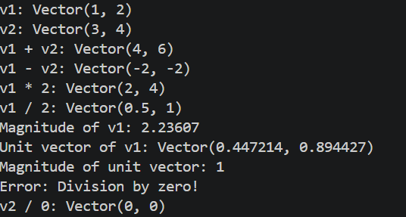
Q4.
#include <iostream>
using namespace std;

class Person {
private:
string name;
string occupation;
public:
Person(string name, string occupation) : name(name), occupation(occupation) {}

virtual void draw() {
cout << "A person can draw in many ways" << endl;
}
};

class Artist : public Person {
public:
Artist(string name) : Person(name, "Artist") {}

void draw() override {
cout << "An artist can draw with a paint brush" << endl;
}
};

class Gunman : public Person {
public:
Gunman(string name) : Person(name, "Gunman") {}

void draw() override {
cout << "A gunman draws a gun to shoot" << endl;
}
};

int main() {
Person *arr[3];
arr[0] = new Person("ABC", "CS Grad");
arr[1] = new Artist("XYZ");
arr[2] = new Gunman("PQR");
for (int i = 0; i < 3; i++) {
arr[i]->draw();
}
return 0;
}

